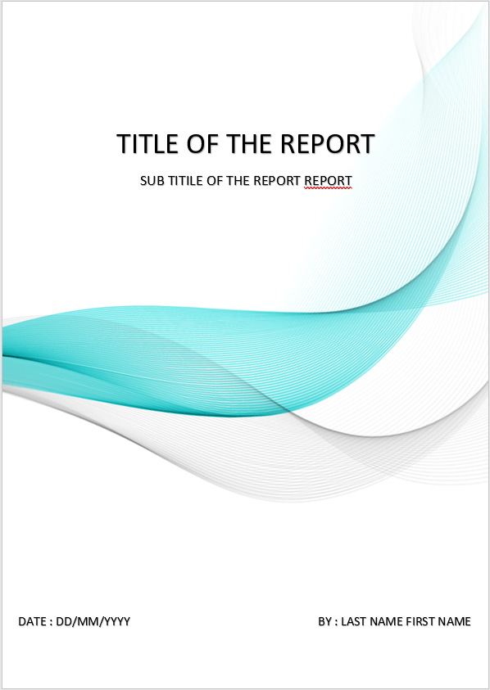

សកលវិទ្យាល័យ​ ពុទ្ធិសាស្រ្តា

University of Puthisastra

Website Project

**Topic:** Promotion Ads

Lecturer : Lypengleang Seang

Course : Dynamic Web App

Year : III

Semester : II

Academic Year: 2019 – 2020

**By Group I**

Mr. Hing Kosal

Ms. Kong Sreya

Mr. Chhorn SokTheng

Date : 20 / 07 / 2020

**Dynamic Web Development Report**

**Week I**

**What is the project about?**

* We advertise product promotions for companies and seller to customers through our website.

**Why we choose this topic?**

* We choose this topic for 3 main reasons
  + - We focusing on developing an alternative for people to get all promotions productions from different companies and seller from the market in to one place so people easy to find and buy better.
    - Help seller to published there promotions productions to the world so their target customer will easy to see.
    - In future it can grow to become online market for people over the world can sell and buy many products easy in one place.

**What is our goal of making this happen?**

**Our Goal:**

This website provides sellers and customers the best experience to post their promotion products to customer and all the promotion ads will post on the website and give many different promotions products so all people over the world will see. First, seller need to register in our system to become our user then they can post their promotion products in different categories to the website. Second, all posts will display in website in different categories and with detail of product and company with sell that product such ask product old price, discount(%), company name, contact, location…etc. We start this process in Cambodia the first location then push to publish over the world. Next Goal when we get a lot of our client and this website popular for all people we will develop this website not only promotions ads but we can sell and buy it will make more easy life. Final goal we want to see this website is become a big online market or people all over the world.

**How my team build this platform?**

Basically, we scratch the user interface and we decide to have 2 different platform Frontend for customer to see all promotions and Backend for seller (our client) where they can post all their promotions products. We have 3 members so we give different job for everyone:

**Responsive Part of Members**

* **Hing Kosal**: Team Leader & Full stack
* **Chhorn Soktheng**: Frontend interface + Login & Register
* **Kong Sreya**: Backend interface
* All members have to response all document

First, we built both static of frontend and backend by using other free template on internet and using HTML, CSS, JAVASCRIPT,​and BOOTSCRAP to edit it by keep template or form we want and add our own template, then delete what we don’t want. Third, we also got support from W3school web, YouTube and especially plenty of method and tool from our instructor. Last but not least, we use PHP to make our website to dynamic like input data into database and call data back and using MYSQL as a database management system.

**Week II**

We will update our static web to become a dynamic web by using PHP connect with MYSQL and update more standard interface.

**Our Site Map**

**Reference**

 **Frontend Template**

<https://coderthemes.com/ubold/layouts/creative/dashboard-2.html>

**Backend Template**

 <https://pixinvent.com/modern-admin-clean-bootstrap-4-dashboard-html-template/html/ltr/vertical-modern-menu-template/index.html>

**Database Structure**

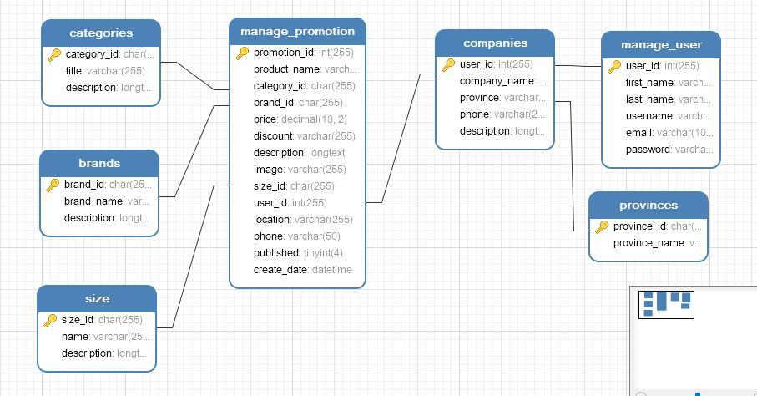

**Our Platform**

* **Frontend**

Homepage

Where we can view all promotion product by category.

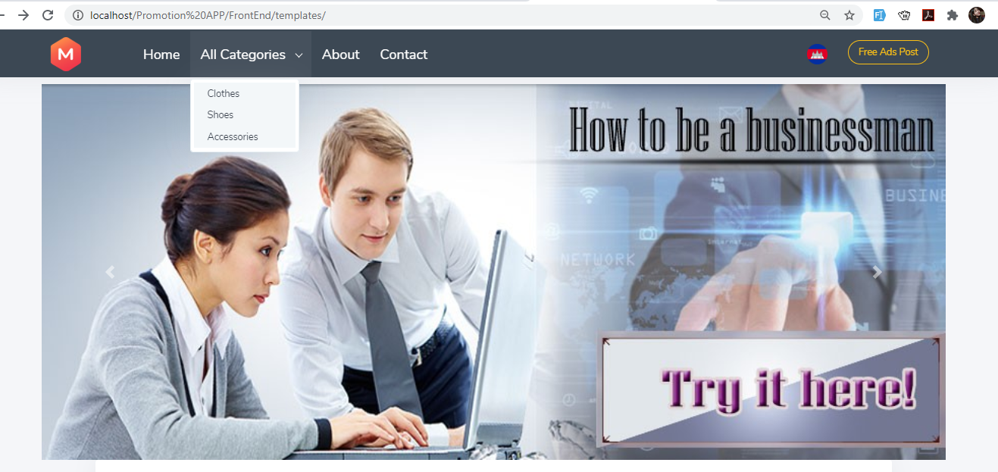

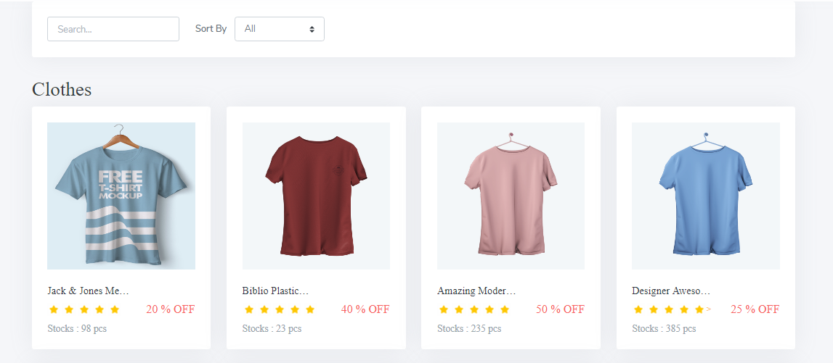

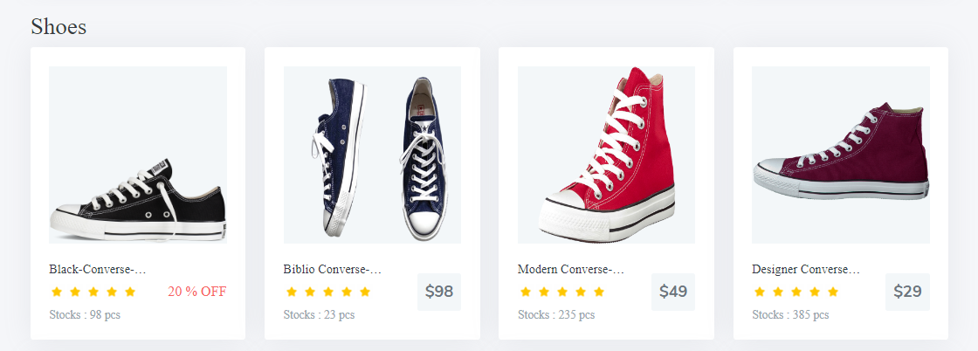

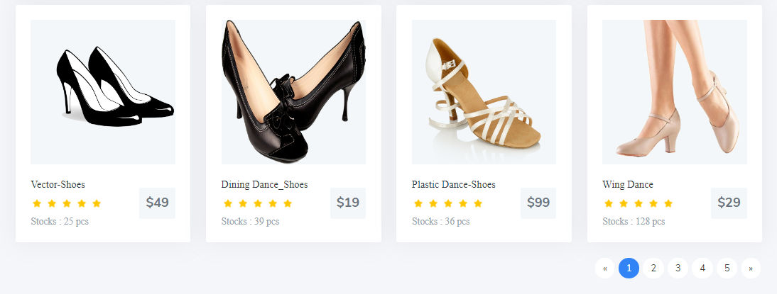

Product Detail

Where we can view detail of a promotion product.

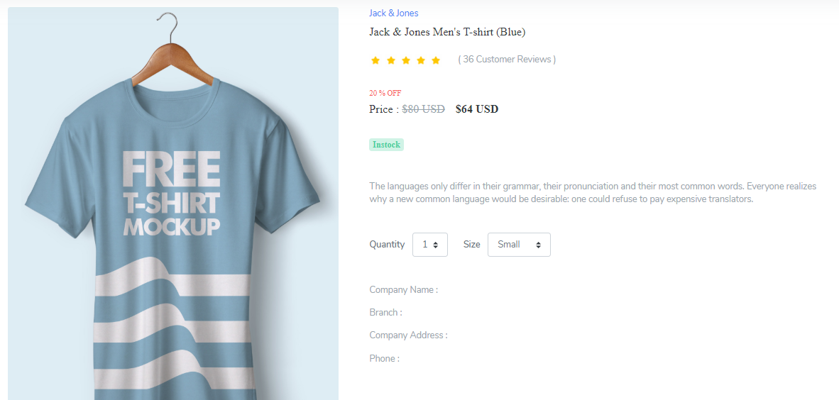

Register Form

Where we can register new user account use for login to backend system management

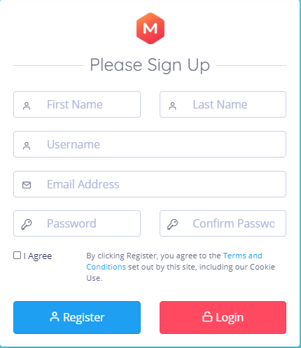

Login Form

You need to have Email and password from user account that already register to login into backend then you can post your promotion ads.

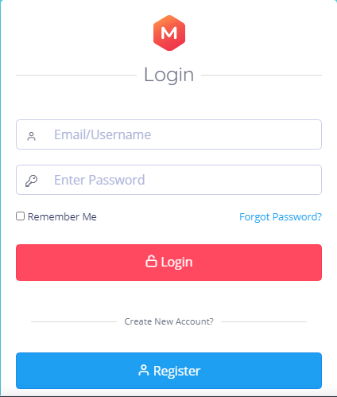

About Us

About is you will see our future goal and our team members.

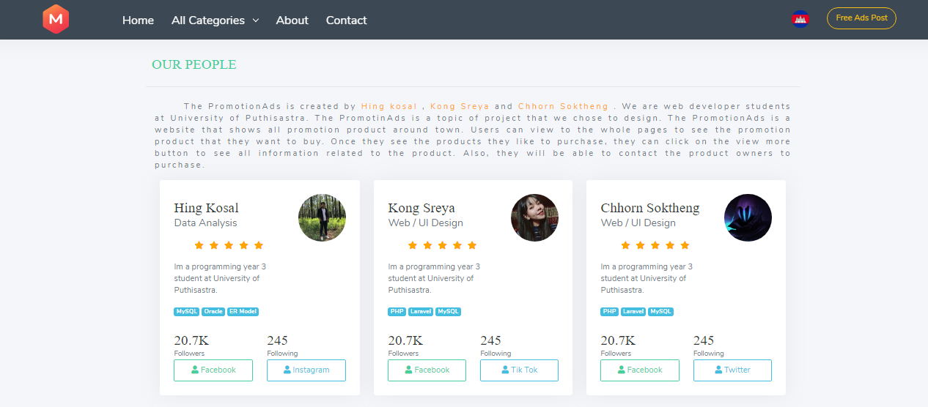

Contact Us

where you can send us message and contact us over the social media and Phone

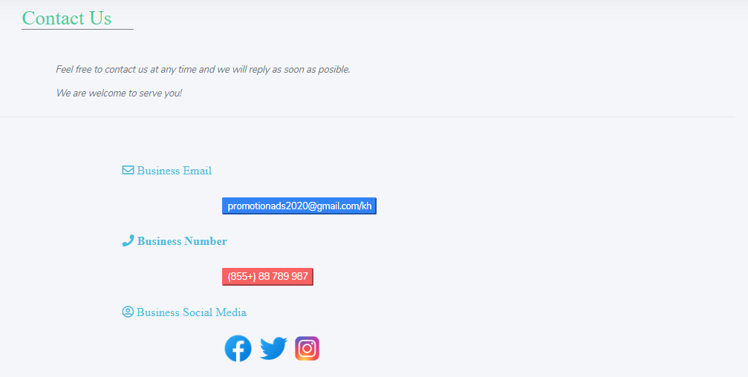

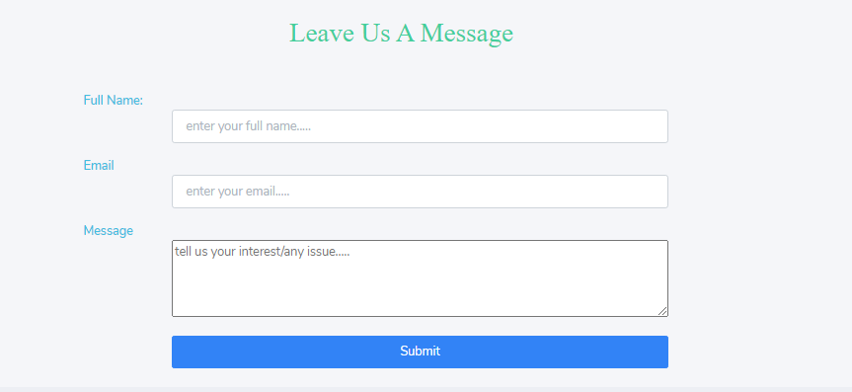

* **Backend**

Dashboard

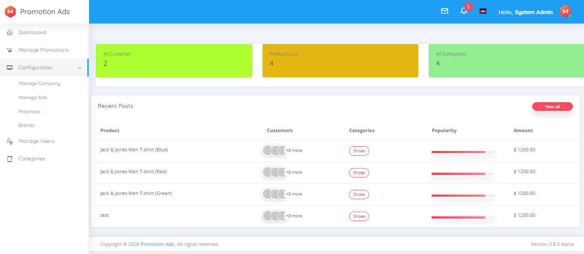

Promotion Products

Promotion Product is where we can see all promotion post.

- We can add, update, delete, and view

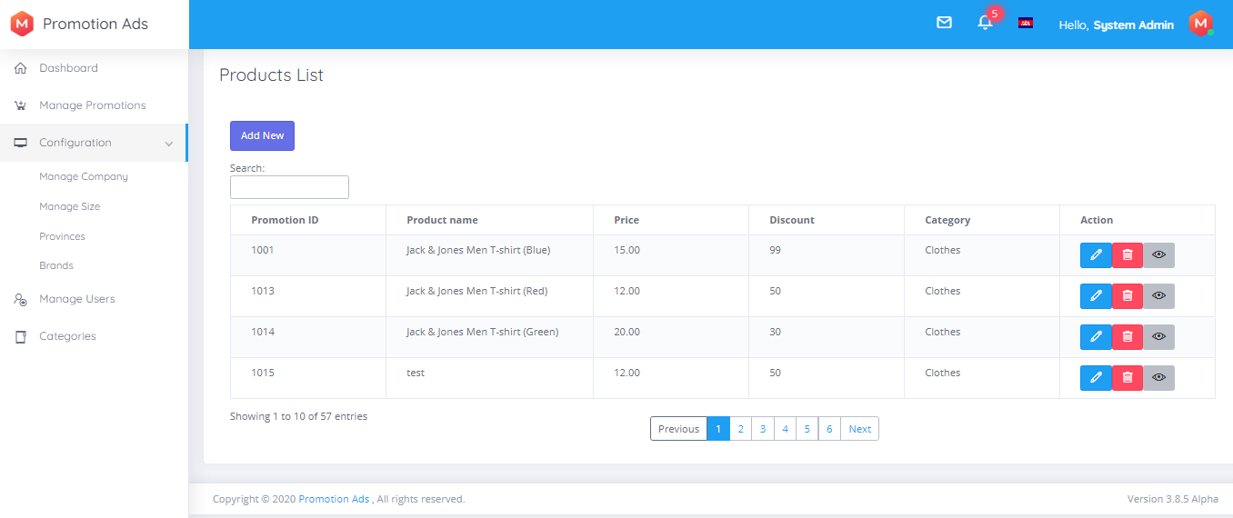

Add New Promotion

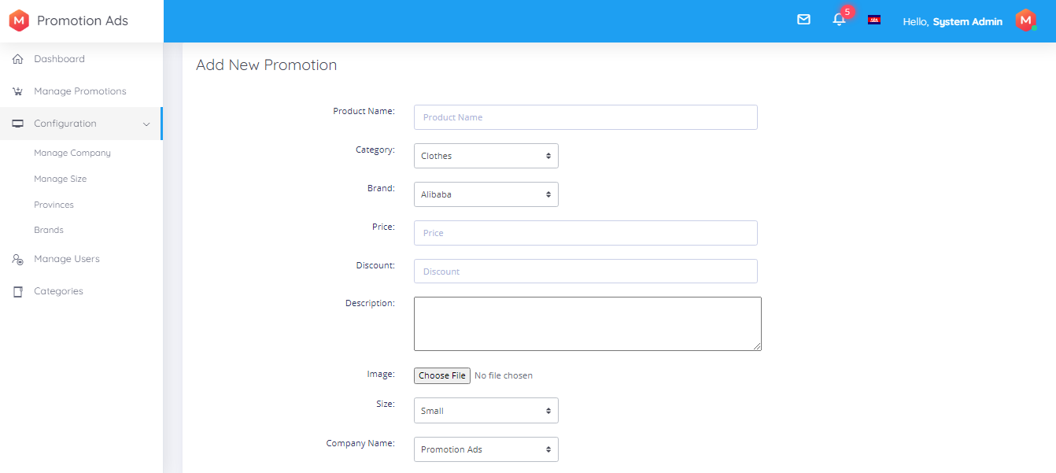

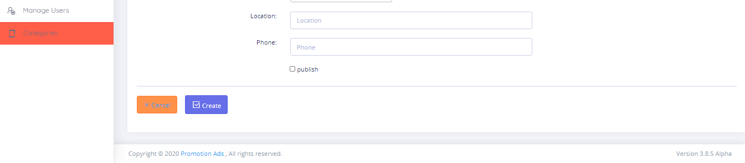

Update Promotion

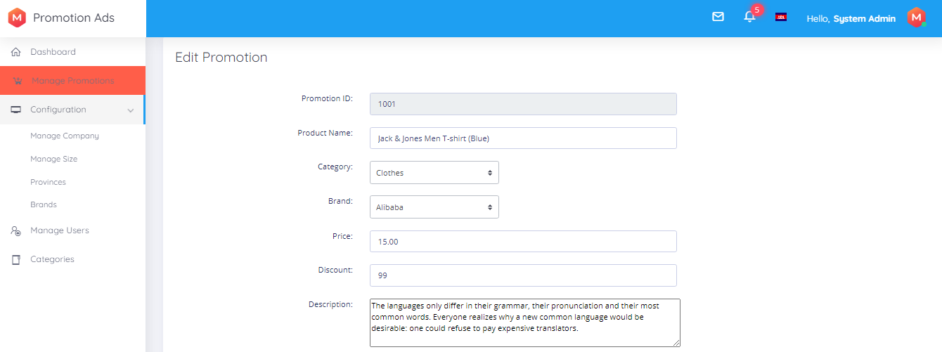

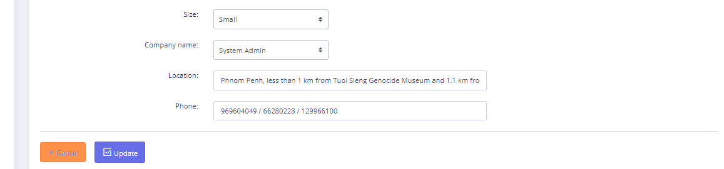

View Promotion

We can view in specific promotion product.

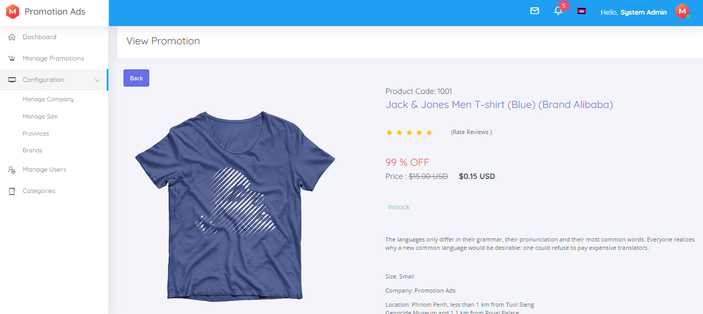

Manage Company

Company of product before post promotion ads all product need to have company.

- View lists: view all Company.

- We can add, update and delete

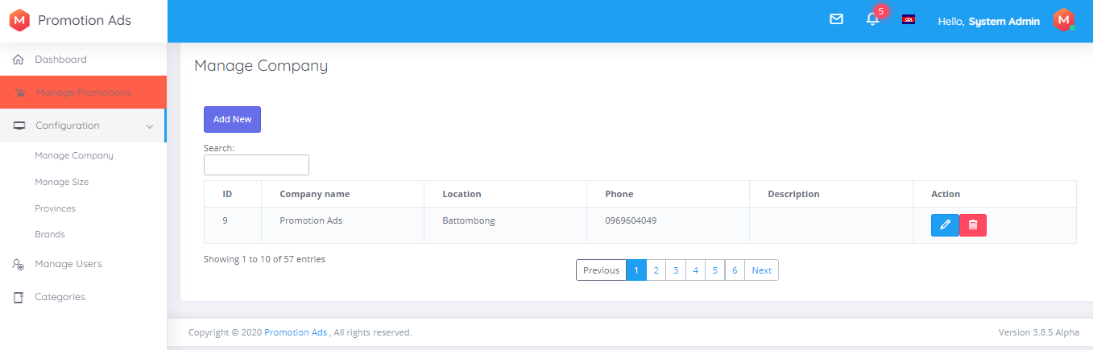

Add New Company

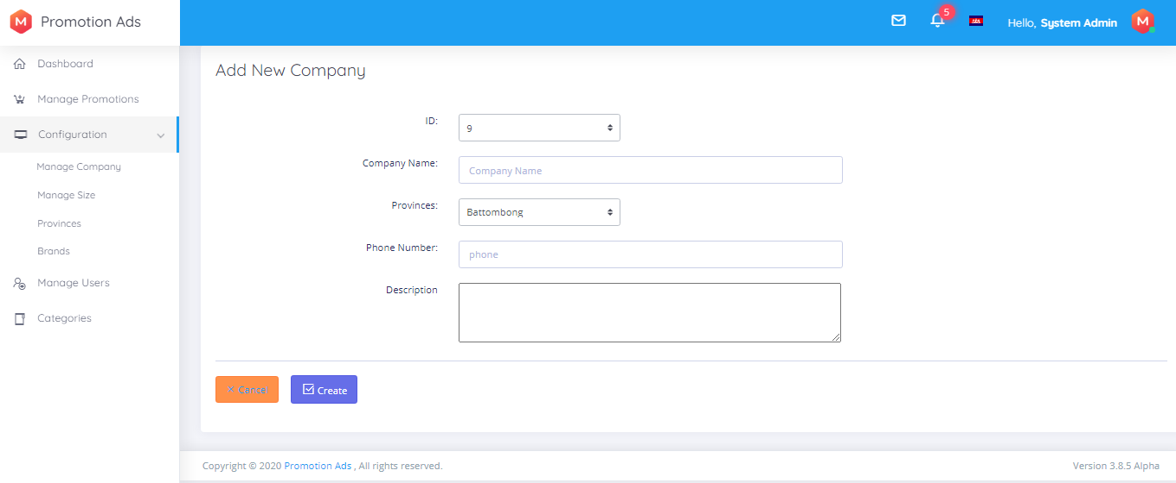

Update Company

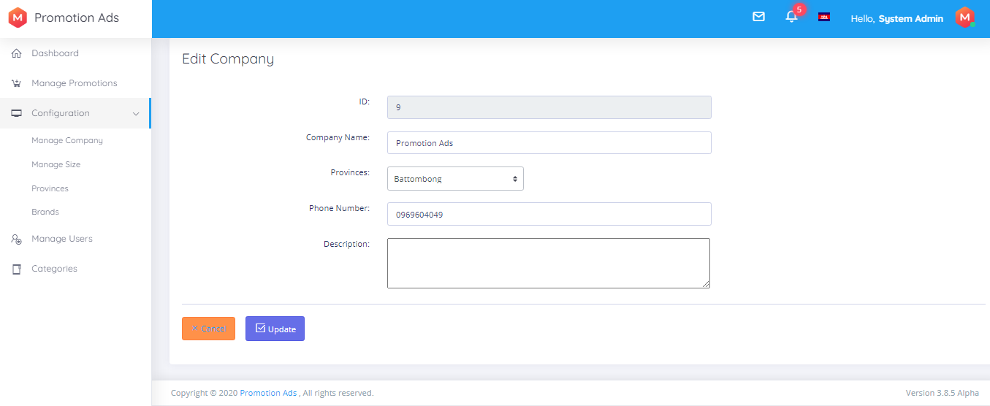

Manage Size

Size is about product size like clothes or shoes...

- View lists: view all size.

- We can add, update and delete

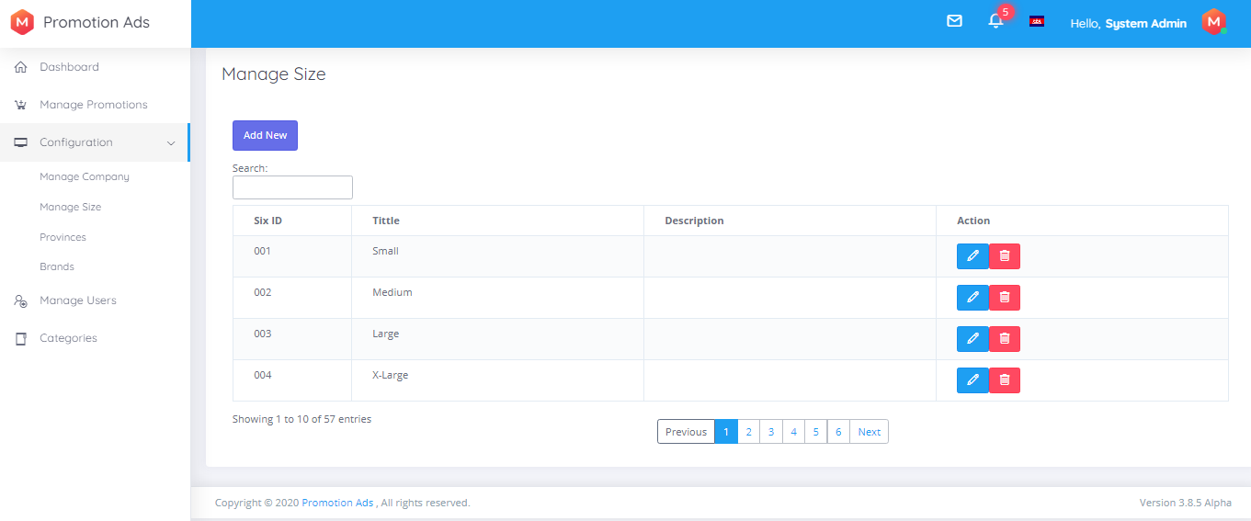

Add New Size

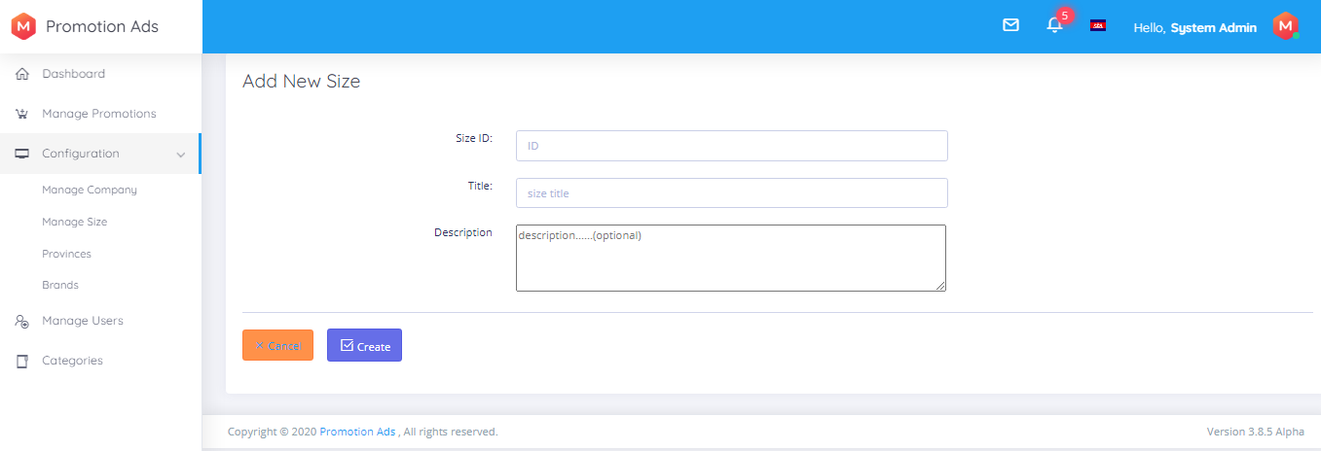

Update Size

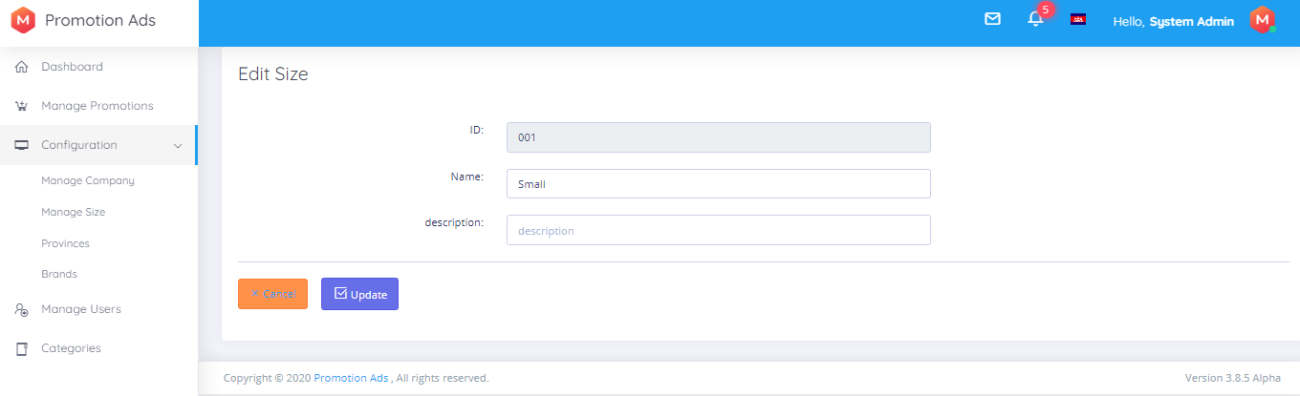

Provinces

Province is about location of company.

- View lists: view all province.

- We can add, update and delete

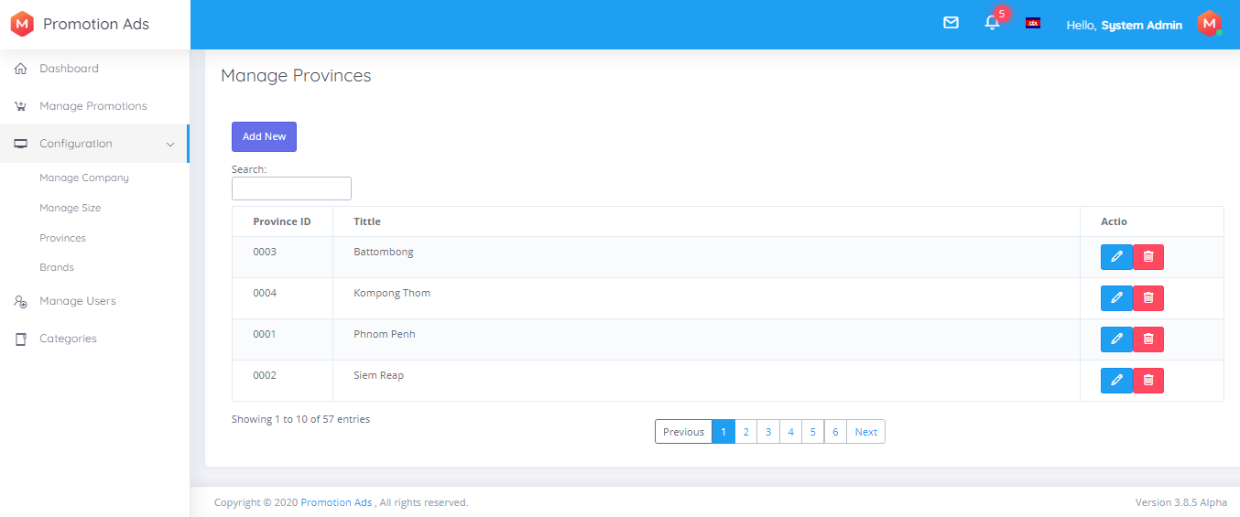

Add New Provinces

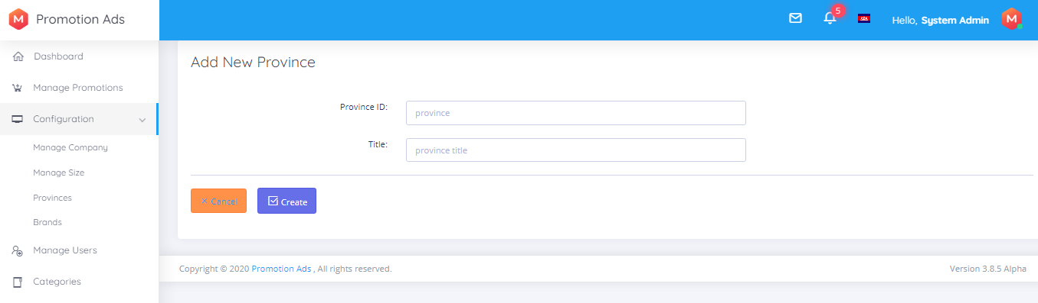

Update Provinces

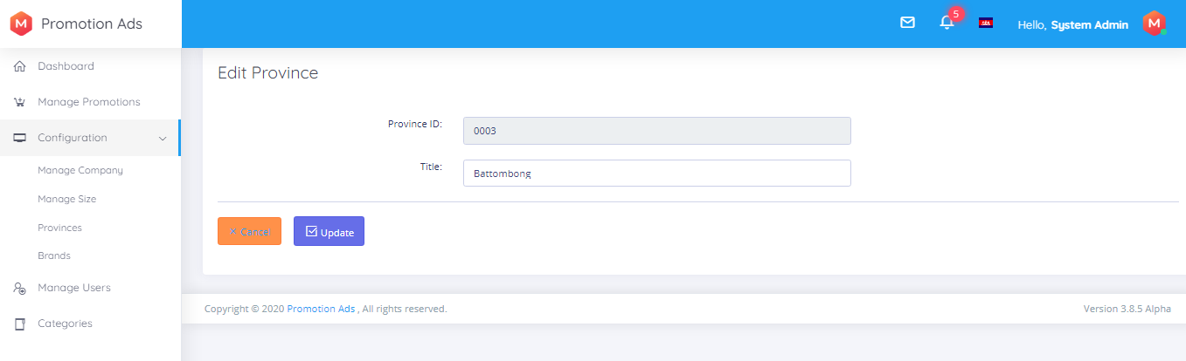

Brands

Brand is focus on product brand.

- View lists: view all product brand in the system.

- We can add, update and delete

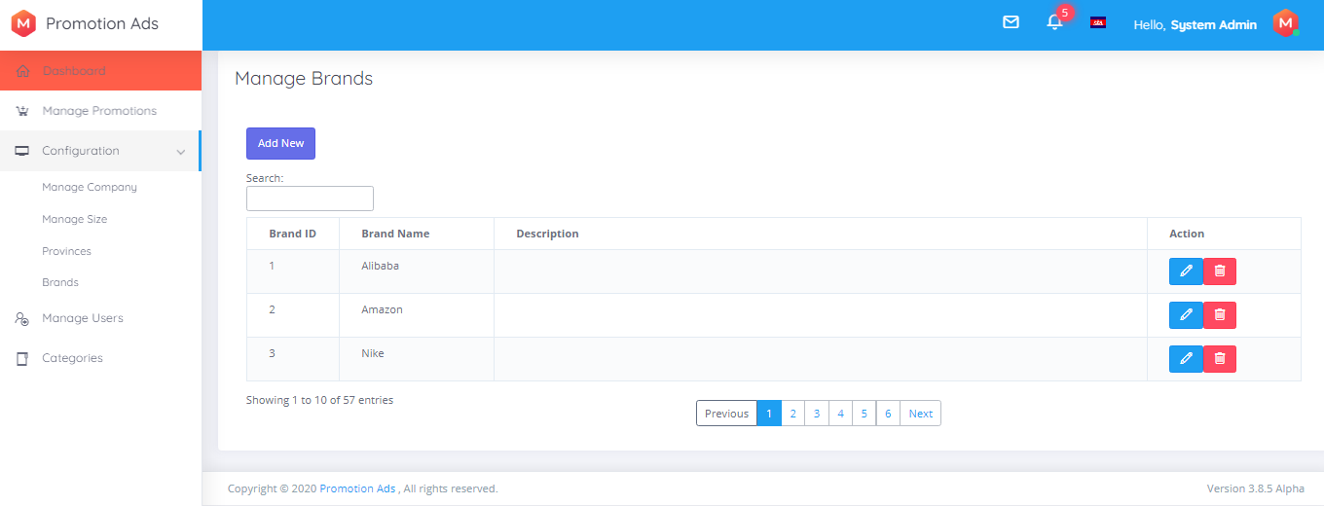

Add New Brands

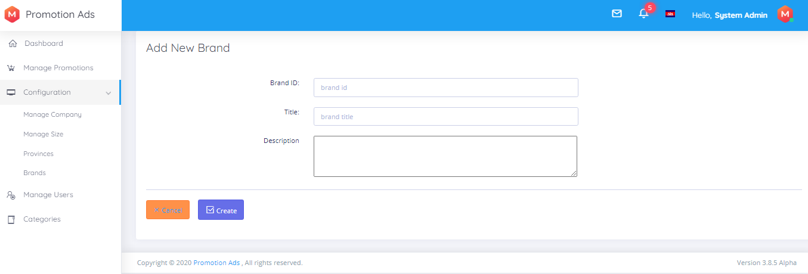

Update Brands

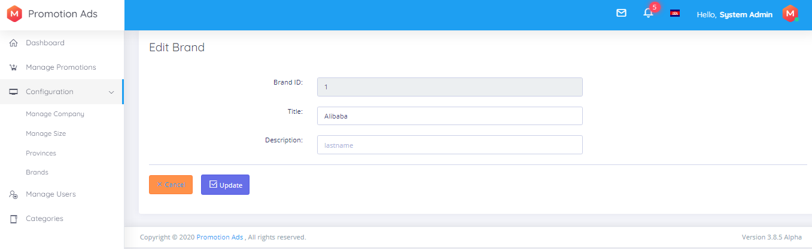

Manage Users

User use to login the backend of the system and can post new promotion ads.

- We can only view list of users

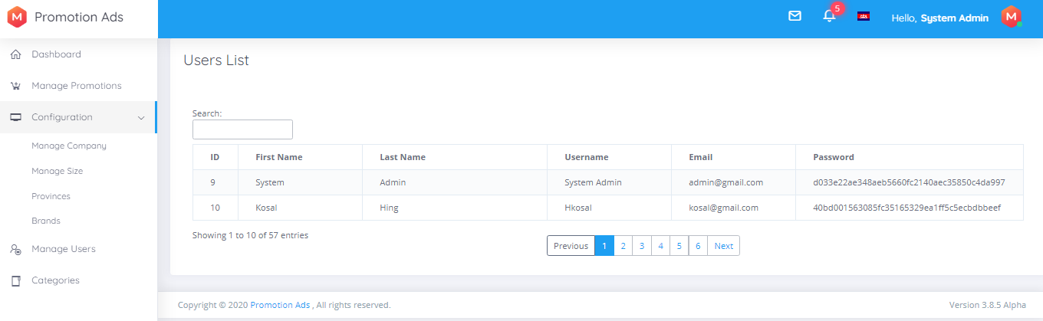

Categories

Category is different kinds of products.

- View lists: view all category system have.

- We can add, update and delete

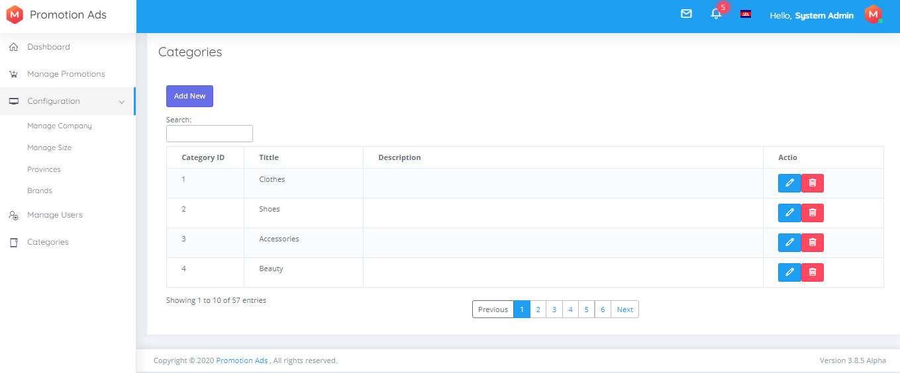

Add New Category

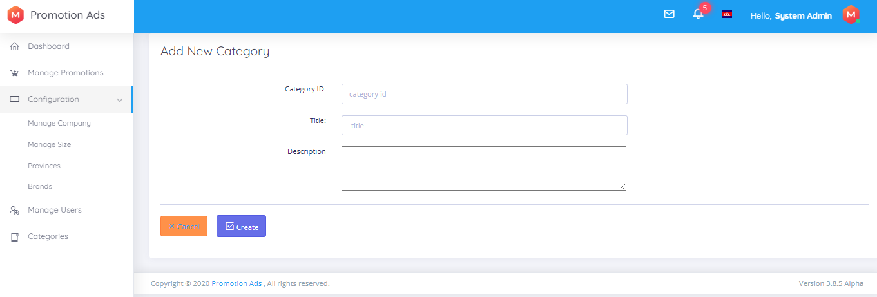

Update Category

